Untitled

VISHAL PATNAIK DAMODARAPATRUNI - s3811521

17/08/2021

# Introduction

The ASX data consists the monthly changes in all ordinaries (Ords) Price Index, Gold price (AUD), Crude Oil (Brent, USD/bbl) and Copper (USD/tonne) for 161 months, starting from 2004. This data is converted to Time series data.

Here, the time series data is analyzed for presence of stationary as well as the impact of components on the series data, then the respective models are fit on the series data to find the best model.

# Scope

This analysis has three parts: Part 1: Checking for Non - Stationary Part 2: Impact of components on the series data Part 3: Identifying the best fit model for ASX price index

## Part 1:

Identifying the trend and change in variance which makes the series stationary. Finally, performing Augumented Dicky Fuller test that says whether the series is stationary or not.

## Part 2:

Using suitable decomposition method analyse the impact of individual components on the series data.

## Part 3:

Finding the suitable distributed lag model among different models that best fits the ASX price index series.

# Method

Using the below packages (forecast, TSA, tseries, expsmooth, funitRoots etc.) the time series data is visualized and analysed based on the stationarity and the decomposed components. Then the best distributed lag model for the ASX price index is selected.

library(expsmooth) # Forecasting with Exponential Smoothing. [1] - https://cran.r-project.org/web/packages/expsmooth/index.html  
library(dplyr)  
library(forecast) # Forecasting Functions for Time Series and Linear Models. [2] - https://cran.r-project.org/web/packages/forecast/index.html  
library(tseries) # Time Series Analysis and Computational Finance.[3] - https://cran.r-project.org/web/packages/tseries/index.html  
library(fUnitRoots) # To analyze trends and unit roots in financial time series. [4] - https://cran.r-project.org/web/packages/fUnitRoots/index.html  
library(TSA) # Time Series Analysis.  
library(urca) # Unit Root and Cointegration Tests. [5] - https://cran.r-project.org/web/packages/urca/index.html  
library(readr)  
library(dLagM) # Distributed lag model.  
library(VIF)  
library(car)

# Data

The data is the monthly averages of all ordinaries (Ords) Price Index, Gold price (AUD), Crude Oil (Brent, USD/bbl) and Copper (USD/tonne). The data starts from 2004 and ends after 161 months. The dataset is in csv format and hence it is loaded using “read.csv()” function.

v_ASX_data <- read.csv("ASX_data.csv", header = TRUE)  
head(v_ASX_data)

## ASX.price Gold.price Crude.Oil..Brent._USD.bbl Copper_USD.tonne  
## 1 2935.4 611.9 31.29 1,650  
## 2 2778.4 603.3 32.65 1,682  
## 3 2848.6 565.7 30.34 1,656  
## 4 2970.9 538.6 25.02 1,588  
## 5 2979.8 549.4 25.81 1,651  
## 6 2999.7 535.9 27.55 1,685

# Using str() to check the type of each column.  
str(v_ASX_data)

## 'data.frame': 161 obs. of 4 variables:  
## $ ASX.price : num 2935 2778 2849 2971 2980 ...  
## $ Gold.price : chr "611.9" "603.3" "565.7" "538.6" ...  
## $ Crude.Oil..Brent._USD.bbl: num 31.3 32.6 30.3 25 25.8 ...  
## $ Copper_USD.tonne : chr "1,650" "1,682" "1,656" "1,588" ...

As the columns Gold.price and Copper_USD.tonne are in char format, which are supposed to be numeric. Now let us convert them into numeric format. For this let us remove “,” before converting.

# Removing Commas  
v_ASX_data$Gold.price = gsub(",","", v_ASX_data$Gold.price)  
v_ASX_data$Copper_USD.tonne = gsub(",","", v_ASX_data$Copper_USD.tonne)  
  
# Converting char to numeric  
v_ASX_data$Gold.price = as.numeric(as.character(v_ASX_data$Gold.price))  
v_ASX_data$Copper_USD.tonne = as.numeric(as.character(v_ASX_data$Copper_USD.tonne))

str(v_ASX_data)

## 'data.frame': 161 obs. of 4 variables:  
## $ ASX.price : num 2935 2778 2849 2971 2980 ...  
## $ Gold.price : num 612 603 566 539 549 ...  
## $ Crude.Oil..Brent._USD.bbl: num 31.3 32.6 30.3 25 25.8 ...  
## $ Copper_USD.tonne : num 1650 1682 1656 1588 1651 ...

Checking Missing values.

colSums(is.na(v_ASX_data))

## ASX.price Gold.price Crude.Oil..Brent._USD.bbl   
## 0 0 0   
## Copper_USD.tonne   
## 0

There are no missing values in the data.

Checking the class of v_ASX_data. (It should be data frame.)

class(v_ASX_data)

## [1] "data.frame"

Converting each column into different time series objects. Here, I am taking start (2004, 1) because the data is monthly and is from 2004. Also, end (2017, 5) because there are 161 observations indicating 161 months which gives 13 years and 5 months. Frequency is 12 as there are 12 months in an year.

v_ASX_price_TS <- ts(v_ASX_data$ASX.price, start = c(2004, 1), end = c(2017, 5), frequency = 12)  
v_GOLD_price_TS <- ts(v_ASX_data$Gold.price, start = c(2004, 1), end = c(2017, 5), frequency = 12)  
v_CRUDE_price_TS <- ts(v_ASX_data$Crude.Oil..Brent._USD.bbl, start = c(2004, 1), end = c(2017, 5), frequency = 12)  
v_COPPER_price_TS <- ts(v_ASX_data$Copper_USD.tonne, start = c(2004, 1), end = c(2017, 5), frequency = 12)

Confirming the class of each time series object.

class(v_ASX_price_TS)

## [1] "ts"

class(v_GOLD_price_TS)

## [1] "ts"

class(v_CRUDE_price_TS)

## [1] "ts"

class(v_COPPER_price_TS)

## [1] "ts"

Now let us visualize each time series object.

# ASX price

plot(v_ASX_price_TS, type = "b", xlab = "years", ylab = "Price index", main = "ASX price change from 2004-1 to 2017-5 (161 months)", pch = 1)  
legend("bottomright", inset = .03, title = "ASX price", legend = "ASX price series", horiz = TRUE, cex = 0.8, lty = 1, box.lty = 2, box.lwd = 2, pch = 1)

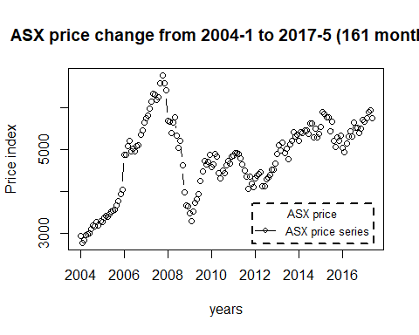

Fig 1: ASX price change - Time series plot.

McLeod.Li.test(y = v_ASX_price_TS, main = "McLeod-Li Test Statistics for ASX price index")

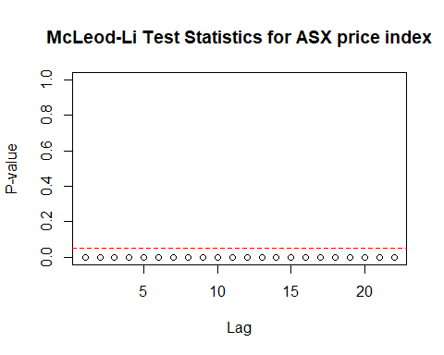

Fig 2: McLeod-Li Test Statistics for ASX price index.

Descriptive analysis

1. From fig1, we can observe an upward trend in the plot until 2017 with an intervention in the year 2008.
2. The ASX price series shows Autoregressive and moving average behaviour.
3. From fig1, we can conclude that there is no seasonality in the series.
4. From fig1 and fig2, we can see there a change in variance.

# GOLD price

plot(v_GOLD_price_TS, type = "b", xlab = "years", ylab = "Price index", main = "GOLD price change from 2004-1 to 2017-5 (161 months)", pch = 1)  
legend("bottomright", inset = .03, title = "GOLD price", legend = "GOLD price series", horiz = TRUE, cex = 0.8, lty = 1, box.lty = 2, box.lwd = 2, pch = 1)

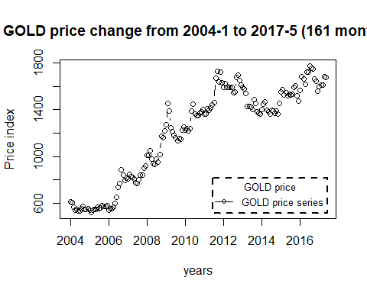

Fig 3: Gold price change - Time series plot.

McLeod.Li.test(y = v_GOLD_price_TS, main = "McLeod-Li Test Statistics for GOLD price index")

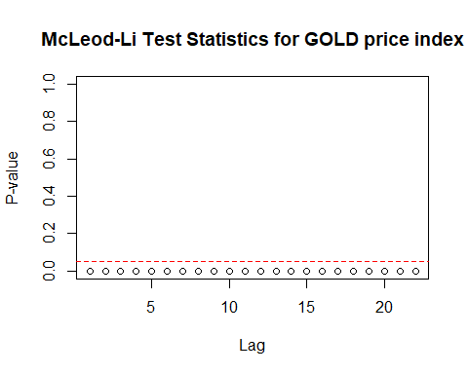

Fig 4: McLeod-Li Test Statistics for GOLD price index.

Descriptive analysis

1. From fig1, we can observe an upward trend in the plot until 2017 with no intervention in the trend.
2. The GOLD price series shows Autoregressive and moving average behaviour.
3. From fig1, we can conclude that there is no seasonality in the series.
4. From fig1 and fig2, we can see a change in variance.

# CRUDE price

plot(v_CRUDE_price_TS, type = "b", xlab = "years", ylab = "Price index", main = "CRUDE OIL price change from 2004-1 to 2017-5 (161 months)", pch = 1)  
legend("topright", inset = .03, title = "CRUDE OIL price", legend = "CRUDE OIL price series", horiz = TRUE, cex = 0.7, lty = 1, box.lty = 2, box.lwd = 2, pch = 1)

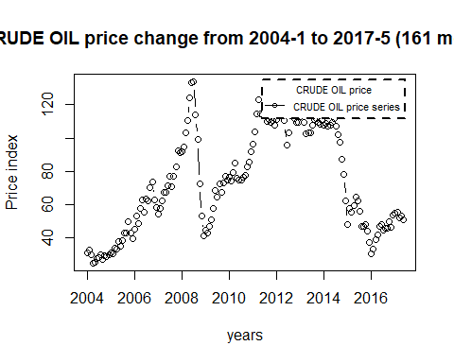

Fig 5: Crude Oil price change - Time series plot.

McLeod.Li.test(y = v_CRUDE_price_TS, main = "McLeod-Li Test Statistics for CRUDE price index")

## 

Fig 6: McLeod-Li Test Statistics for CRUDE price index.

Descriptive analysis

1. From fig1, we can observe an upward trend in the plot until 2007 with an intervention in the year 2008 and again an upward trent till 2012 which later followed a downward patern.
2. The CRUDE price series shows Autoregressive and moving average behaviour.
3. From fig1, we can conclude that there is no seasonality in the series.
4. From fig1 and fig2, we can see there is a change in variance.

# COPPER price

plot(v_COPPER_price_TS, type = "b", xlab = "years", ylab = "Price index", main = "COPPER price change from 2004-1 to 2017-5 (161 months)", pch = 1)  
legend("bottomright", inset = .03, title = "COPPER price", legend = "COPPER price series", horiz = TRUE, cex = 0.8, lty = 1, box.lty = 2, box.lwd = 2, pch = 1)

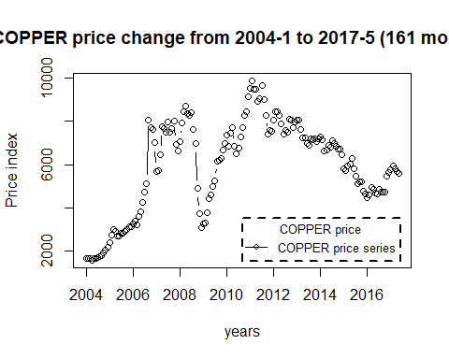

Fig 7: COPPER price change - Time series plot.

McLeod.Li.test(y = v_COPPER_price_TS, main = "McLeod-Li Test Statistics for COPPER price index")

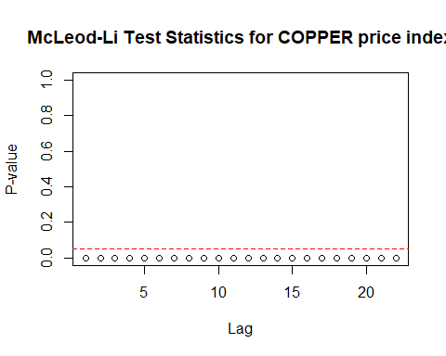

Fig 6: McLeod-Li Test Statistics for COPPER price index.

Descriptive analysis

1. From fig1, we can observe that the trend is almost similar to COPPER series following an upward trend until 2008 with an intervention in the year 2009 and again an upward trend till 2011 which later followed a downward patern.
2. The COPPER price series shows Autoregressive and moving average behaviour.
3. From fig1, we can conclude that there is no seasonality in the series.
4. From fig1 and fig2, we can see there is a change in variance.

## The existence of Non - Stationary

# Function to check Stationary on the series.   
Stationary_Check <- function(x) {  
   
 # Analysing trends by plotting ACF and PACF.  
 par(mfrow = c(1,2))  
 acf(x, main = "Price change - ACF")  
 pacf(x, main = "Price change - PACF")  
   
 # Conducting Augmented Dickey-Fuller test.  
 adf.test(x)  
}

Checking for Stationary on ASX price

Stationary_Check(v_ASX_price_TS)

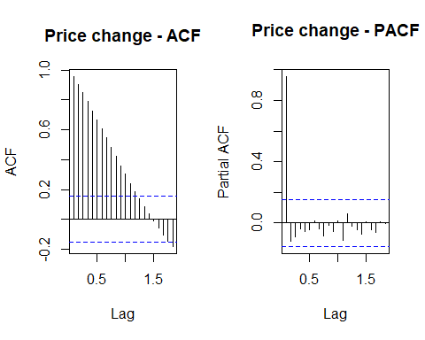

##   
## Augmented Dickey-Fuller Test  
##   
## data: x  
## Dickey-Fuller = -2.6995, Lag order = 5, p-value = 0.2846  
## alternative hypothesis: stationary

Fig 9: ASX price change - ACF Fig 10: ASX price change - PACF

The decrease in the ACF plot and a high peak in the PACF plot in the beginning, suggests that there is some pattern in the ASX price trend.

Hypotheses : H0 : The data is not stationary. HA : The data is stationary.

Interpretations: p - value : 0.2846 > 0.5

p - value is greater than 0.5 and hence the test is not statistically significant. Therefore, we fail to reject Null hypothesis i.e., The data is not stationary.

Also, as there is change in variance suggesting that the series is not stationary.

Therefore, the ASX price series is non - stationary.

Checking for Stationary on GOLD price

Stationary_Check(v_GOLD_price_TS)

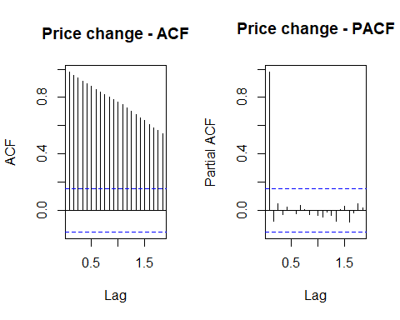

##   
## Augmented Dickey-Fuller Test  
##   
## data: x  
## Dickey-Fuller = -1.8369, Lag order = 5, p-value = 0.6444  
## alternative hypothesis: stationary

Fig 11: GOLD price change - ACF Fig 12: GOLD price change - PACF

The decrease in the ACF plot and a high peak in the PACF plot in the beginning, suggests that there is some pattern in the GOLD price trend.

Hypotheses : H0 : The data is not stationary. HA : The data is stationary.

Interpretations: p - value : 0.6444 > 0.5

p - value is greater than 0.5 and hence the test is not statistically significant. Therefore, we fail to reject Null hypothesis i.e., The data is not stationary.

Also, as there is change in variance suggesting that the series is not stationary.

Therefore, the GOLD price series is non - stationary.

Checking for Stationary on CRUDE price

Stationary_Check(v_CRUDE_price_TS)

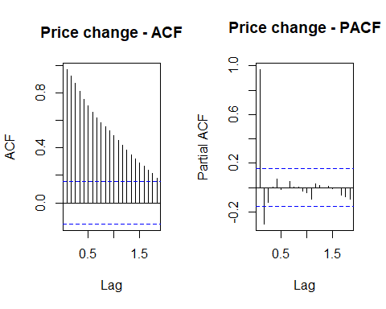

##   
## Augmented Dickey-Fuller Test  
##   
## data: x  
## Dickey-Fuller = -1.8523, Lag order = 5, p-value = 0.6379  
## alternative hypothesis: stationary

Fig 13: CRUDE price change - ACF Fig 14: CRUDE price change - PACF

The decrease in the ACF plot and a high peak in the PACF plot in the beginning, suggests that there is some pattern in the CRUDE price trend.

Hypotheses : H0 : The data is not stationary. HA : The data is stationary.

Interpretations: p - value : 0.6379 > 0.5

p - value is greater than 0.5 and hence the test is not statistically significant. Therefore, we fail to reject Null hypothesis i.e., The data is not stationary.

Also, as there is change in variance suggesting that the series is not stationary.

Therefore, the CRUDE price series is non - stationary.

Checking for Stationary on COPPER price

Stationary_Check(v_COPPER_price_TS)

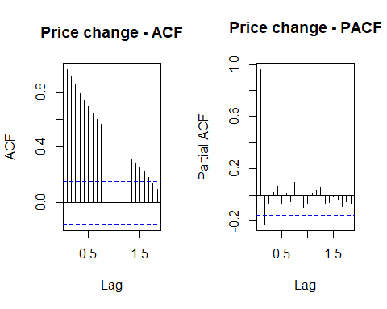

##   
## Augmented Dickey-Fuller Test  
##   
## data: x  
## Dickey-Fuller = -2.2502, Lag order = 5, p-value = 0.472  
## alternative hypothesis: stationary

Fig 15: COPPER price change - ACF Fig 16: COPPER price change - PACF

The decrease in the ACF plot and a high peak in the PACF plot in the beginning, suggests that there is some pattern in the COPPER price trend.

Hypotheses : H0 : The data is not stationary. HA : The data is stationary.

Interpretations: p - value : 0.472 > 0.5

p - value is greater than 0.5 and hence the test is not statistically significant. Therefore, we fail to reject Null hypothesis i.e., The data is not stationary.

Also, as there is change in variance suggesting that the series is not stationary.

Therefore, the COPPER price series is non - stationary.

## Impact of components on each time series.

The components of a series are usually,

1. Seasonality
2. Trend
3. Remainder

We should decompose the time series into the above components as we can see the impact of these components on the series data.

For this STL decomposition is used, as there is intervention in some of the series. This intervention is might be due to outliers and STL decomposition is robust in the case of outliers.

Decomposing ASX price series into components.

v_ASX_stl_decomp <- stl(v_ASX_price_TS, t.window = 15, s.window = "periodic", robust = TRUE)   
plot(v_ASX_stl_decomp, main = "Decomposing ASX price Series into components")

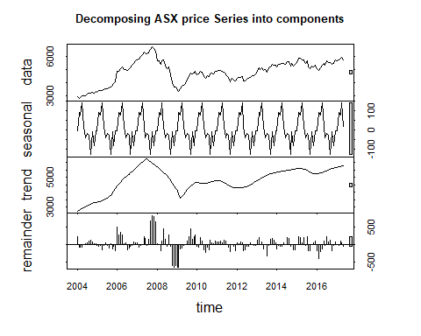

Fig 17: Decomposing ASX price series into components - stl decomposition.

1. The seasonal adjusted series is not meaningful in this case as it much deviated from the original series. Suggesting that there is no seasonality in the series as stated earlier.
2. The trend in the series data is shown exactly by the trend component.
3. Remainder component shows a high intervention point around 2008 depicting the real time global financial effect.

Decomposing GOLD price series into components.

v_GOLD_stl_decomp <- stl(v_GOLD_price_TS, t.window = 15, s.window = "periodic", robust = TRUE)   
plot(v_GOLD_stl_decomp, main = "Decomposing GOLD price Series into components")

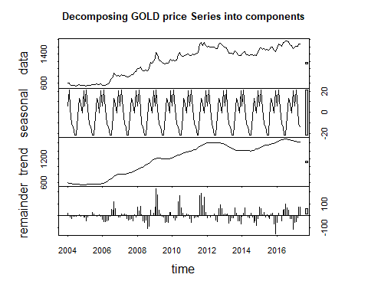

Fig 18: Decomposing GOLD price series into components - stl decomposition.

1. The seasonal adjusted series is not meaningful in this case as it much deviated from the original series. Suggesting that there is no seasonality in the series as stated earlier.
2. The trend in the series data is shown exactly by the trend component.
3. Remainder component shows a high intervention point at multiple points.

Decomposing CRUDE price series into components.

v_CRUDE_stl_decomp <- stl(v_CRUDE_price_TS, t.window = 15, s.window = "periodic", robust = TRUE)   
plot(v_CRUDE_stl_decomp, main = "Decomposing CRUDE price Series into components")

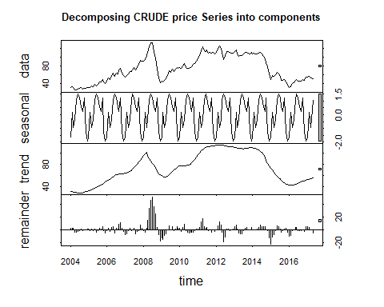

Fig 19: Decomposing CRUDE price series into components - stl decomposition.

1. The seasonal adjusted series is not meaningful in this case as it much deviated from the original series. Suggesting that there is no seasonality in the series as stated earlier.
2. The trend in the series data is shown exactly by the trend component.
3. Remainder component shows a high intervention point in 2008 depicting the real time global financial effect.

Decomposing COPPER price series into components.

v_COPPER_stl_decomp <- stl(v_COPPER_price_TS, t.window = 15, s.window = "periodic", robust = TRUE)   
plot(v_COPPER_stl_decomp, main = "Decomposing COPPER price Series into components")

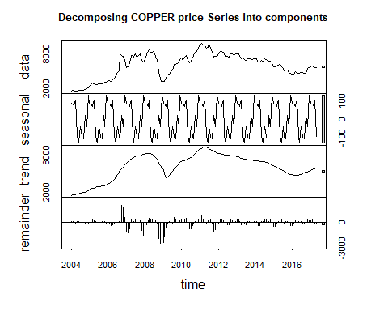

Fig 20: Decomposing COPPER price series into components - stl decomposition.

1. The seasonal adjusted series is not meaningful in this case as it much deviated from the original series. Suggesting that there is no seasonality in the series as stated earlier.
2. The trend in the series data is shown exactly by the trend component.
3. Remainder component shows a high intervention point around 2008 depicting the real time global financial effect.

## Suitable distributed lag model for ASX price index.

ASX price index W.R.T Copper price series

# Finite distributed lag model

x = v_COPPER_price_TS # Independent variable1  
z = v_GOLD_price_TS # Independent variable2  
y = v_ASX_price_TS # Dependent variable  
  
  
for ( i in 1:10){  
 model_1 = dlm(x = as.vector(x) , y = as.vector(y), q = i )  
 cat("q = ", i, "AIC = ", AIC(model_1$model), "BIC = ", BIC(model_1$model),"\n")  
 }

## q = 1 AIC = 2574.488 BIC = 2586.789   
## q = 2 AIC = 2559.356 BIC = 2574.7   
## q = 3 AIC = 2544.155 BIC = 2562.531   
## q = 4 AIC = 2528.895 BIC = 2550.289   
## q = 5 AIC = 2513.265 BIC = 2537.664   
## q = 6 AIC = 2497.775 BIC = 2525.166   
## q = 7 AIC = 2481.988 BIC = 2512.357   
## q = 8 AIC = 2466.511 BIC = 2499.846   
## q = 9 AIC = 2451.016 BIC = 2487.302   
## q = 10 AIC = 2436.164 BIC = 2475.389

As we have the least AIC and BIC values at q = 10. Let us fit the finite distributed lag model with q = 10.

# Finite lag length based on AIC-BIC  
  
finite_dlm_copper = dlm( x = as.vector(x) , y = as.vector(y), q = 10)  
summary(finite_dlm_copper)

##   
## Call:  
## lm(formula = model.formula, data = design)  
##   
## Residuals:  
## Min 1Q Median 3Q Max   
## -1154.09 -643.75 -11.55 596.33 1429.23   
##   
## Coefficients:  
## Estimate Std. Error t value Pr(>|t|)   
## (Intercept) 3.981e+03 2.166e+02 18.382 <2e-16 ***  
## x.t 1.536e-01 1.354e-01 1.134 0.259   
## x.1 1.857e-02 2.205e-01 0.084 0.933   
## x.2 4.480e-02 2.220e-01 0.202 0.840   
## x.3 2.830e-02 2.180e-01 0.130 0.897   
## x.4 1.889e-02 2.175e-01 0.087 0.931   
## x.5 -4.846e-02 2.191e-01 -0.221 0.825   
## x.6 3.046e-02 2.175e-01 0.140 0.889   
## x.7 -3.494e-03 2.189e-01 -0.016 0.987   
## x.8 -1.349e-03 2.239e-01 -0.006 0.995   
## x.9 -8.232e-02 2.222e-01 -0.371 0.712   
## x.10 -1.012e-02 1.340e-01 -0.076 0.940   
## ---  
## Signif. codes: 0 '***' 0.001 '**' 0.01 '*' 0.05 '.' 0.1 ' ' 1  
##   
## Residual standard error: 737.4 on 139 degrees of freedom  
## Multiple R-squared: 0.1931, Adjusted R-squared: 0.1292   
## F-statistic: 3.024 on 11 and 139 DF, p-value: 0.001201  
##   
## AIC and BIC values for the model:  
## AIC BIC  
## 1 2436.164 2475.389

Hypotheses : H0 : The data doesn′t fit the Finite distributed lag model. HA : The data fits the Finite distributed lag model.

Interpretations: F - statistic is 3.024 R - squared is 0.1931 Adjusted R - squared is 0.1292 Degrees of freedom - DF are (11, 139) p - value (0.001201) is < 0.05 and therefore, it is statistically significant. Therefore, Null hypothesis is rejected. Hence, the model fits the Finite distributed lag model.

This model suggests that there is only 19.31% of data variance. Suggesting that the model explains only 19.31% of the trend. Which implies that the model shows some trend.

## Residual analysis

# Function for residual analysis.  
  
res_analysis <- function(res_m) {  
   
 par(mfrow = c(2, 2))  
 # Scatter plot for model residuals  
 plot(res_m, type = "b", pch = 19, col = "blue", xlab = "years", ylab = "Standardized Residuals", main = "Plot of Residuals over Time")  
  
 abline(h = 0)  
   
 # Standard distribution  
 hist(res_m, xlab = 'Standardized Residuals', freq = FALSE)  
 curve(dnorm(x, mean = mean(res_m), sd = sd(res_m)), col = "red", lwd = 2, add = TRUE, yaxt = "n")  
   
 # QQplot for model residuals  
 qqnorm(res_m, col = c("blue"))  
 qqline(res_m)  
   
 # Auto-Correlation Plot  
 acf(res_m, main = "ACF of Standardized Residuals",col=c("blue"))  
}

res_analysis(residuals(finite_dlm_copper$model))

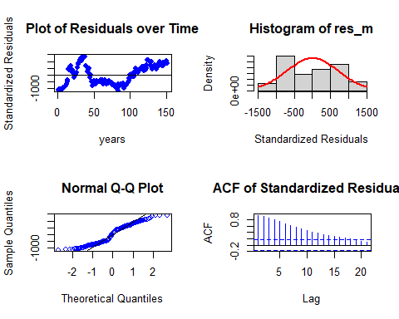

Residual Analysis for Finite DLM:

1. The data points are below the line at the start and below the line at the end of the trend. Randomness is seen to some extent. So, we cannot decide anything at this stage. Further analysis is required.
2. From normal distribution curve, the distribution is almost symmetric and requires some transformation to make it symmetric. This suggests the non - stationary in the series.
3. The data at the tails is deviated more leaving some part on the line suggesting there is no normality in the trend.
4. There are significant lags in Autocorrelation plot suggesting that the stochastic component is not white noise.

Therefore, Further analysis is needed by adding polynomial to the lag model.

# Polynomial distributed lag model

for (i in 1:3){  
 model_2 <- polyDlm(x = as.vector(x) , y = as.vector(y), q = i , k = i, show.beta = FALSE)  
 cat("q = ", i, "k = ", i, "AIC = ", AIC(model_2$model), "BIC = ", BIC(model_2$model),"\n")  
}

## q = 1 k = 1 AIC = 2574.488 BIC = 2586.789   
## q = 2 k = 2 AIC = 2559.356 BIC = 2574.7   
## q = 3 k = 3 AIC = 2544.155 BIC = 2562.531

Let us fit a polynomial model of order 3. Since least AIC and BIC scores.

# Ploynomial DLM  
  
PolyDLM_model_copper = polyDlm(x = as.vector(x), y = as.vector(y), q = 3, k = 3, show.beta = TRUE)

## Estimates and t-tests for beta coefficients:  
## Estimate Std. Error t value P(>|t|)  
## beta.0 0.1680 0.131 1.290 0.201  
## beta.1 0.0419 0.210 0.199 0.842  
## beta.2 0.0636 0.210 0.302 0.763  
## beta.3 -0.0578 0.129 -0.448 0.655

summary(PolyDLM_model_copper)

##   
## Call:  
## "Y ~ (Intercept) + X.t"  
##   
## Residuals:  
## Min 1Q Median 3Q Max   
## -1332.00 -699.29 -97.89 621.39 1553.44   
##   
## Coefficients:  
## Estimate Std. Error t value Pr(>|t|)   
## (Intercept) 3539.99286 185.97839 19.034 <2e-16 ***  
## z.t0 0.16811 0.13081 1.285 0.201   
## z.t1 -0.29701 1.04763 -0.284 0.777   
## z.t2 0.21928 0.96450 0.227 0.820   
## z.t3 -0.04846 0.21330 -0.227 0.821   
## ---  
## Signif. codes: 0 '***' 0.001 '**' 0.01 '*' 0.05 '.' 0.1 ' ' 1  
##   
## Residual standard error: 742.7 on 153 degrees of freedom  
## Multiple R-squared: 0.2733, Adjusted R-squared: 0.2543   
## F-statistic: 14.39 on 4 and 153 DF, p-value: 5.404e-10

Hypotheses : H0 : The data doesn′t fit the Polynomial distributed lag model. HA : The data fits the Polynomial distributed lag model.

Interpretations: F - statistic is 14.39 R - squared is 0.2733 Adjusted R - squared is 0.2543 Degrees of freedom - DF are (4, 153) p - value (0.01) is < 0.05 and therefore, it is statistically significant. Therefore, Null hypothesis is rejected. Hence, the model fits the Polynomial distributed lag model.

This model suggests that there is only 27.33% of data variance. Suggesting that the model explains only 27.33% of the trend. Which implies that the model shows some trend.

## Residual analysis

res_analysis(residuals(PolyDLM_model_copper$model))

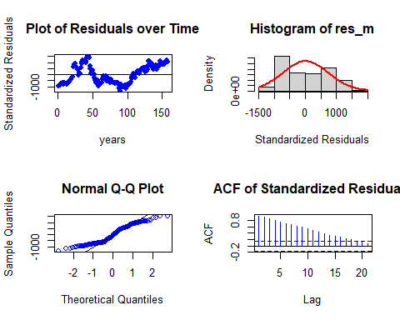

Residual Analysis for Polynomial DLM:

1. The data points are below the line at the start and below the line at the end of the trend. Randomness is seen to some extent. So, we cannot decide anything at this stage. Further analysis is required.
2. From normal distribution curve, the distribution is almost symmetric and requires some transformation to make it symmetric. This suggests the non - stationary in the series.
3. The data at the tails is deviated more leaving some part on the line suggesting there is no normality in the trend.
4. There are significant lags in Autocorrelation plot suggesting that the stochastic component is not white noise.

This analysis is not enough and we still require a better model than this. Therefore, let us fit Koyck model.

# Koyck model

# Koyk DLM  
  
Koyck_DLM_copper = koyckDlm(x = as.vector(x) , y = as.vector(y))  
summary(Koyck_DLM_copper)

##   
## Call:  
## "Y ~ (Intercept) + Y.1 + X.t"  
##   
## Residuals:  
## Min 1Q Median 3Q Max   
## -689.64 -108.62 12.78 140.20 771.79   
##   
## Coefficients:  
## Estimate Std. Error t value Pr(>|t|)   
## (Intercept) 189.368812 87.644648 2.161 0.0322 *   
## Y.1 0.971621 0.021895 44.376 <2e-16 ***  
## X.t -0.005864 0.009517 -0.616 0.5387   
## ---  
## Signif. codes: 0 '***' 0.001 '**' 0.01 '*' 0.05 '.' 0.1 ' ' 1  
##   
## Residual standard error: 201.9 on 157 degrees of freedom  
## Multiple R-Squared: 0.9485, Adjusted R-squared: 0.9479   
## Wald test: 1448 on 2 and 157 DF, p-value: < 2.2e-16   
##   
## Diagnostic tests:  
## NULL  
##   
## alpha beta phi  
## Geometric coefficients: 6672.885 -0.005863623 0.9716211

Hypotheses : H0 : The data doesn′t fit the Koyck distributed lag model. HA : The data fits the Koyck distributed lag model.

Interpretations: Walt test - statistic is 1448 R - squared is 0.9485 Adjusted R - squared is 0.9479 Degrees of freedom - DF are (2, 157) p - value (0.01) is < 0.05 and therefore, it is statistically significant. Therefore, Null hypothesis is rejected. Hence, the model fits the Koyck distributed lag model.

This model suggests that there is only 94.85% of data variance. Suggesting that the model explains only 94.85% of the trend. Which implies that the model performs better on the series data.

Now let us perform residual analysis.

## Residual analysis

res_analysis(residuals(Koyck_DLM_copper))

## 2 3 4 5 6 7   
## -253.202914 -30.610848 23.082621 -86.477237 -75.025302 12.803618   
## 8 9 10 11 12 13   
## 5.298155 -114.678300 18.261437 -170.880048 24.533185 -103.752494   
## 14 15 16 17 18 19   
## 8.852679 -32.170263 -83.952475 -27.466232 -2.098674 -56.865123   
## 20 21 22 23 24 25   
## -56.258419 41.535921 44.158599 92.935178 51.235104 771.792699   
## 26 27 28 29 30 31   
## -32.861153 176.884448 95.956039 -253.719314 38.523936 -95.592640   
## 32 33 34 35 36 37   
## 104.053203 35.245022 240.940477 115.938747 189.540536 117.568097   
## 38 39 40 41 42 43   
## 66.356304 175.905107 205.263342 213.917574 3.463459 -86.583649   
## 44 45 46 47 48 49   
## 91.002511 365.530625 242.621700 -141.692507 -135.968325 -689.639612   
## 50 51 52 53 54 55   
## -3.431458 -243.873540 262.447878 137.163954 -417.990992 -268.934588   
## 56 57 58 59 60 61   
## 161.681077 -584.660135 -677.835397 -364.478905 -80.335251 -247.606666   
## 62 63 64 65 66 67   
## -252.350187 161.705150 149.290705 12.444825 82.742609 255.096471   
## 68 69 70 71 72 73   
## 202.046722 229.415809 -110.296909 50.285608 152.562166 -293.406077   
## 74 75 76 77 78 79   
## 35.557299 228.407743 -64.382442 -392.363504 -153.655477 155.549369   
## 80 81 82 83 84 85   
## -87.231932 180.025045 87.330525 -62.445827 167.511796 7.078568   
## 86 87 88 89 90 91   
## 79.904245 11.079317 -23.496061 -108.066932 -129.399854 -159.845072   
## 92 93 94 95 96 97   
## -139.488905 -316.487992 259.891585 -197.000699 -99.959552 189.269180   
## 98 99 100 101 102 103   
## 45.284433 16.731182 31.851697 -349.789770 -26.704157 126.361650   
## 104 105 106 107 108 109   
## 25.995248 48.492013 112.049456 -32.844966 132.156466 226.632804   
## 110 111 112 113 114 115   
## 216.382610 -139.689291 182.996258 -254.784471 112.830231 -266.261379   
## 116 117 118 119 120 121   
## 338.187556 90.458999 203.539204 -100.085239 42.550965 -142.702300   
## 122 123 124 125 126 127   
## 210.564995 -9.092880 70.895949 9.292441 -85.832876 246.174124   
## 128 129 130 131 132 133   
## 12.765403 -317.254300 208.671523 -200.700159 89.282101 160.744259   
## 134 135 136 137 138 139   
## 348.671923 -23.746229 -75.816805 12.622825 -314.981263 227.827780   
## 140 141 142 143 144 145   
## -457.665890 -174.081084 214.773110 -81.539022 112.319064 -299.473074   
## 146 147 148 149 150 151   
## -127.601504 183.995301 149.606796 120.822879 -144.947561 323.454909   
## 152 153 154 155 156 157   
## -115.940495 -8.962756 -127.629175 95.901847 216.671093 -37.428029   
## 158 159 160 161   
## 92.511097 151.071498 55.297228 -174.052323

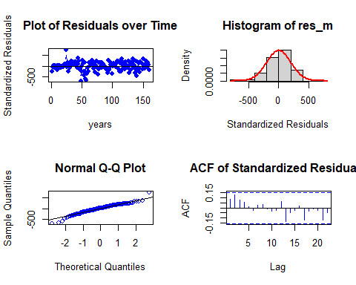

Residual Analysis for Koyck DLM:

1. The data points are below the line at both the start and end of the trend. Randomness is not seen here.
2. From normal distribution curve, the distribution is almost symmetric. This suggests a good fit with a very few data falling outside the normal curve indicating Kurtosis.
3. The data at the tails is deviated but is normal for most part of the line suggesting normality in the trend.
4. There are no significant lags in Autocorrelation plot suggesting that the stochastic component is white noise.

So far this is the best model but let us fit ardlDlm model to check whether it fits better than Koyck model or not.

# Autoregressive distributed lag model

for (i in 1:10){  
 for(j in 1:5){  
 model_4 = ardlDlm(x = as.vector(x) , y = as.vector(y), p = i , q = j )  
 cat("p = ", i, "q = ", j, "AIC = ", AIC(model_4$model), "BIC = ", BIC(model_4$model),"\n")  
 }  
}

## p = 1 q = 1 AIC = 2147.741 BIC = 2163.116   
## p = 1 q = 2 AIC = 2135.4 BIC = 2153.813   
## p = 1 q = 3 AIC = 2121.12 BIC = 2142.558   
## p = 1 q = 4 AIC = 2109.759 BIC = 2134.209   
## p = 1 q = 5 AIC = 2099.056 BIC = 2126.505   
## p = 2 q = 1 AIC = 2130.043 BIC = 2148.456   
## p = 2 q = 2 AIC = 2132.038 BIC = 2153.52   
## p = 2 q = 3 AIC = 2119.241 BIC = 2143.741   
## p = 2 q = 4 AIC = 2107.649 BIC = 2135.155   
## p = 2 q = 5 AIC = 2097.021 BIC = 2127.52   
## p = 3 q = 1 AIC = 2117.307 BIC = 2138.745   
## p = 3 q = 2 AIC = 2119.247 BIC = 2143.748   
## p = 3 q = 3 AIC = 2119.696 BIC = 2147.259   
## p = 3 q = 4 AIC = 2108.537 BIC = 2139.1   
## p = 3 q = 5 AIC = 2097.832 BIC = 2131.38   
## p = 4 q = 1 AIC = 2105.916 BIC = 2130.366   
## p = 4 q = 2 AIC = 2107.774 BIC = 2135.28   
## p = 4 q = 3 AIC = 2108.608 BIC = 2139.17   
## p = 4 q = 4 AIC = 2110.085 BIC = 2143.704   
## p = 4 q = 5 AIC = 2099.454 BIC = 2136.052   
## p = 5 q = 1 AIC = 2095.118 BIC = 2122.566   
## p = 5 q = 2 AIC = 2096.96 BIC = 2127.459   
## p = 5 q = 3 AIC = 2097.887 BIC = 2131.436   
## p = 5 q = 4 AIC = 2099.497 BIC = 2136.095   
## p = 5 q = 5 AIC = 2101.419 BIC = 2141.067   
## p = 6 q = 1 AIC = 2084.49 BIC = 2114.924   
## p = 6 q = 2 AIC = 2086.331 BIC = 2119.809   
## p = 6 q = 3 AIC = 2087.163 BIC = 2123.684   
## p = 6 q = 4 AIC = 2088.704 BIC = 2128.268   
## p = 6 q = 5 AIC = 2090.603 BIC = 2133.211   
## p = 7 q = 1 AIC = 2072.833 BIC = 2106.239   
## p = 7 q = 2 AIC = 2074.698 BIC = 2111.141   
## p = 7 q = 3 AIC = 2075.535 BIC = 2115.016   
## p = 7 q = 4 AIC = 2077.211 BIC = 2119.729   
## p = 7 q = 5 AIC = 2079.174 BIC = 2124.729   
## p = 8 q = 1 AIC = 2062.338 BIC = 2098.703   
## p = 8 q = 2 AIC = 2064.181 BIC = 2103.577   
## p = 8 q = 3 AIC = 2065.007 BIC = 2107.433   
## p = 8 q = 4 AIC = 2066.679 BIC = 2112.135   
## p = 8 q = 5 AIC = 2068.654 BIC = 2117.141   
## p = 9 q = 1 AIC = 2049.983 BIC = 2089.293   
## p = 9 q = 2 AIC = 2051.863 BIC = 2094.197   
## p = 9 q = 3 AIC = 2052.445 BIC = 2097.803   
## p = 9 q = 4 AIC = 2054.13 BIC = 2102.512   
## p = 9 q = 5 AIC = 2056.102 BIC = 2107.508   
## p = 10 q = 1 AIC = 2034.551 BIC = 2076.793   
## p = 10 q = 2 AIC = 2036.144 BIC = 2081.403   
## p = 10 q = 3 AIC = 2036.502 BIC = 2084.779   
## p = 10 q = 4 AIC = 2037.935 BIC = 2089.229   
## p = 10 q = 5 AIC = 2039.913 BIC = 2094.224

p = 10 and q = 1 has the least AIC and BIC scores.

# ARDLM model  
  
AR_DLM_copper = ardlDlm(x = as.vector(x) , y = as.vector(y), p = 10 , q = 1 )  
summary(AR_DLM_copper)

##   
## Time series regression with "ts" data:  
## Start = 11, End = 161  
##   
## Call:  
## dynlm(formula = as.formula(model.text), data = data, start = 1)  
##   
## Residuals:  
## Min 1Q Median 3Q Max   
## -591.71 -104.56 -9.24 126.64 729.10   
##   
## Coefficients:  
## Estimate Std. Error t value Pr(>|t|)   
## (Intercept) 2.362e+02 1.039e+02 2.273 0.0246 *   
## X.t 7.806e-02 3.575e-02 2.183 0.0307 *   
## X.1 -3.751e-02 5.815e-02 -0.645 0.5200   
## X.2 -4.639e-04 5.855e-02 -0.008 0.9937   
## X.3 -1.595e-02 5.751e-02 -0.277 0.7820   
## X.4 -1.247e-02 5.736e-02 -0.217 0.8283   
## X.5 -5.529e-02 5.779e-02 -0.957 0.3404   
## X.6 6.729e-02 5.736e-02 1.173 0.2427   
## X.7 -4.951e-03 5.772e-02 -0.086 0.9318   
## X.8 -4.301e-02 5.904e-02 -0.728 0.4676   
## X.9 -6.099e-02 5.859e-02 -1.041 0.2997   
## X.10 7.708e-02 3.540e-02 2.178 0.0311 *   
## Y.1 9.648e-01 2.237e-02 43.134 <2e-16 ***  
## ---  
## Signif. codes: 0 '***' 0.001 '**' 0.01 '*' 0.05 '.' 0.1 ' ' 1  
##   
## Residual standard error: 194.5 on 138 degrees of freedom  
## Multiple R-squared: 0.9443, Adjusted R-squared: 0.9394   
## F-statistic: 194.9 on 12 and 138 DF, p-value: < 2.2e-16

Hypotheses : H0 : The data doesn′t fit the Autoregressive distributed lag model. HA : The data fits the Autoregressive distributed lag model.

Interpretations: F - statistic is 194.9 R - squared is 0.9443 Adjusted R - squared is 0.9394 Degrees of freedom - DF are (12, 138) p - value (0.01) is < 0.05 and therefore, it is statistically significant. Therefore, Null hypothesis is rejected. Hence, the model fits the Autoregressive distributed lag model.

This model suggests that there is only 94.43% of data variance. Suggesting that the model explains only 94.43% of the trend. Which implies that the model shows some trend.

Let us perform residual analysis on this model.

## Residual analysis

res_analysis(residuals(AR_DLM_copper))

## Time Series:  
## Start = 11   
## End = 161   
## Frequency = 1   
## 11 12 13 14 15 16   
## -208.6351731 -27.8223986 -164.2241618 -57.9984615 -98.8140234 -130.3520955   
## 17 18 19 20 21 22   
## -49.5285799 -12.7876615 -61.9080221 -66.5659847 13.9863700 23.5101249   
## 23 24 25 26 27 28   
## 93.7708791 53.3526685 729.0976415 -79.8309924 168.5590049 66.9160186   
## 29 30 31 32 33 34   
## -297.9795183 -22.5101142 -167.7885088 9.2668982 -254.7238591 101.6371765   
## 35 36 37 38 39 40   
## -9.2423511 157.8843108 243.6849943 278.4677165 128.7998654 93.4043167   
## 41 42 43 44 45 46   
## 228.0045933 143.4354494 -124.4773632 151.3505504 325.8062664 65.5685984   
## 47 48 49 50 51 52   
## -77.1919688 46.8233392 -591.7124400 -45.5162532 -292.0803572 149.8067373   
## 53 54 55 56 57 58   
## 83.6447179 -356.0311800 -233.2927676 127.9226637 -528.4479398 -421.7485341   
## 59 60 61 62 63 64   
## -42.9881766 211.1268364 -121.6908035 -202.3962767 105.5347366 101.1097936   
## 65 66 67 68 69 70   
## -70.0381043 -45.4946356 4.5551237 -22.3643169 114.6934848 -195.9261524   
## 71 72 73 74 75 76   
## -18.5964303 121.1995838 -291.3807455 15.1157684 181.4812661 -64.1711931   
## 77 78 79 80 81 82   
## -279.1829807 -106.9523524 147.9797087 -45.7956741 167.0288196 -39.5104778   
## 83 84 85 86 87 88   
## -162.2146505 147.9106621 -59.0602381 -92.5298652 -39.4770262 -32.6986322   
## 89 90 91 92 93 94   
## 0.8672666 -72.2575714 -147.1567391 -105.7359725 -182.1073837 406.3431483   
## 95 96 97 98 99 100   
## -81.5781285 -26.8740419 125.3551746 -56.5175164 -1.3011635 103.5702017   
## 101 102 103 104 105 106   
## -372.7284424 -23.0985428 90.1244980 53.0840211 7.8873218 132.1393852   
## 107 108 109 110 111 112   
## 2.6055485 144.1225404 201.1664425 197.5100293 -155.3548309 219.4768858   
## 113 114 115 116 117 118   
## -188.5998957 218.3978730 -238.8652271 300.7775017 114.6240091 233.7105258   
## 119 120 121 122 123 124   
## -94.2596437 1.4132487 -157.3542621 211.6735517 14.9748492 92.2186676   
## 125 126 127 128 129 130   
## 52.3041849 -65.9050503 219.4415603 -11.2335502 -276.3418721 252.8734921   
## 131 132 133 134 135 136   
## -210.6538358 99.3772381 232.4005317 414.8464034 10.7167793 -29.8875024   
## 137 138 139 140 141 142   
## -17.3380471 -315.8647182 278.5153221 -373.7783938 -167.6006659 198.5416018   
## 143 144 145 146 147 148   
## -63.0372814 162.2426192 -234.1890175 -74.9078850 131.4875964 89.9892124   
## 149 150 151 152 153 154   
## 106.1482597 -123.3199430 319.1475265 -126.0003042 -37.2455276 -149.9026814   
## 155 156 157 158 159 160   
## 58.2726714 210.5394054 -103.3880990 26.0480610 136.1887682 104.8440667   
## 161   
## -180.3414982

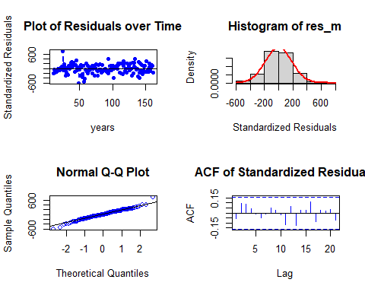

Residual Analysis for Auto Regressive DLM:

1. The data points are below the line at both the start and end of the trend. Randomness is not seen here.
2. From normal distribution curve, the distribution is almost symmetric. This suggests a good fit with a very few data falling outside the normal curve indicating Kurtosis.
3. The data at the tails is deviated but is normal for most part of the line suggesting normality in the trend.
4. There are no significant lags in Autocorrelation plot suggesting that the stochastic component is white noise.

Even though Auto Regressive DLM shown better performance, Koyck model fits better with 94.85% variance.

Also, let us check with respect to Gold series. Since, it has the second highest auto correlation value.

ASX price index W.R.T GOLD price series

# Finite distributed lag model

x = v_GOLD_price_TS # Independent variable  
y = v_ASX_price_TS # Dependent variable  
  
  
for ( i in 1:10){  
 model_1 = dlm(x = as.vector(x) , y = as.vector(y), q = i )  
 cat("q = ", i, "AIC = ", AIC(model_1$model), "BIC = ", BIC(model_1$model),"\n")  
 }

## q = 1 AIC = 2613.609 BIC = 2625.91   
## q = 2 AIC = 2596.292 BIC = 2611.637   
## q = 3 AIC = 2579.215 BIC = 2597.59   
## q = 4 AIC = 2562.296 BIC = 2583.69   
## q = 5 AIC = 2544.887 BIC = 2569.286   
## q = 6 AIC = 2527.575 BIC = 2554.966   
## q = 7 AIC = 2510.535 BIC = 2540.905   
## q = 8 AIC = 2493.885 BIC = 2527.22   
## q = 9 AIC = 2476.983 BIC = 2513.27   
## q = 10 AIC = 2460.345 BIC = 2499.57

As we have the least AIC and BIC values at q = 10. Let us fit the finite distributed lag model with q = 10.

# Finite lag length based on AIC-BIC  
  
finite_dlm_GOLD = dlm( x = as.vector(x) , y = as.vector(y), q = 10)  
summary(finite_dlm_GOLD)

##   
## Call:  
## lm(formula = model.formula, data = design)  
##   
## Residuals:  
## Min 1Q Median 3Q Max   
## -1535.24 -575.79 20.89 480.32 1951.02   
##   
## Coefficients:  
## Estimate Std. Error t value Pr(>|t|)   
## (Intercept) 4523.02779 225.83961 20.028 <2e-16 ***  
## x.t -0.54891 1.27022 -0.432 0.666   
## x.1 0.07699 1.88146 0.041 0.967   
## x.2 -0.01009 1.90952 -0.005 0.996   
## x.3 -0.12278 1.92437 -0.064 0.949   
## x.4 -0.30955 1.92889 -0.160 0.873   
## x.5 0.47310 1.93180 0.245 0.807   
## x.6 0.02590 1.94990 0.013 0.989   
## x.7 0.67162 1.95391 0.344 0.732   
## x.8 -0.11584 1.94844 -0.059 0.953   
## x.9 0.11415 1.92690 0.059 0.953   
## x.10 0.11352 1.28818 0.088 0.930   
## ---  
## Signif. codes: 0 '***' 0.001 '**' 0.01 '*' 0.05 '.' 0.1 ' ' 1  
##   
## Residual standard error: 798.9 on 139 degrees of freedom  
## Multiple R-squared: 0.05296, Adjusted R-squared: -0.02199   
## F-statistic: 0.7066 on 11 and 139 DF, p-value: 0.7306  
##   
## AIC and BIC values for the model:  
## AIC BIC  
## 1 2460.345 2499.57

Hypotheses : H0 : The data doesn′t fit the Finite distributed lag model. HA : The data fits the Finite distributed lag model.

Interpretations: F - statistic is 0.7066 R - squared is 0.05296 Adjusted R - squared is -0.02199 Degrees of freedom - DF are (11, 139) p - value (0.7306) is > 0.05 and therefore, it is not statistically significant. Therefore, Null hypothesis cannot be rejected. Also, this model suggests that there is only 5.3% of data variance. Suggesting that the model explains only 5.3% of the trend. Hence, the model doesn’t fit the Finite distributed lag model.

# Polynomial distributed lag model

for (i in 1:3){  
 model_2 <- polyDlm(x = as.vector(x) , y = as.vector(y), q = i , k = i, show.beta = FALSE)  
 cat("q = ", i, "k = ", i, "AIC = ", AIC(model_2$model), "BIC = ", BIC(model_2$model),"\n")  
}

## q = 1 k = 1 AIC = 2613.609 BIC = 2625.91   
## q = 2 k = 2 AIC = 2596.292 BIC = 2611.637   
## q = 3 k = 3 AIC = 2579.215 BIC = 2597.59

Let us fit a polynomial model of order 3. Since least AIC and BIC scores.

# Ploynomial DLM  
  
PolyDLM_model_GOLD = polyDlm(x = as.vector(x), y = as.vector(y), q = 3, k = 3, show.beta = TRUE)

## Estimates and t-tests for beta coefficients:  
## Estimate Std. Error t value P(>|t|)  
## beta.0 0.15800 1.28 0.123000 0.903  
## beta.1 0.00179 1.92 0.000929 0.999  
## beta.2 0.10300 1.93 0.053200 0.958  
## beta.3 0.39900 1.28 0.311000 0.756

summary(PolyDLM_model_GOLD)

##   
## Call:  
## "Y ~ (Intercept) + X.t"  
##   
## Residuals:  
## Min 1Q Median 3Q Max   
## -1579.25 -662.06 -12.23 540.91 2198.76   
##   
## Coefficients:  
## Estimate Std. Error t value Pr(>|t|)   
## (Intercept) 4058.2998 213.4589 19.012 <2e-16 ***  
## z.t0 0.1575 1.2840 0.123 0.903   
## z.t1 -0.3044 9.6816 -0.031 0.975   
## z.t2 0.1589 8.8853 0.018 0.986   
## z.t3 -0.0102 1.9660 -0.005 0.996   
## ---  
## Signif. codes: 0 '***' 0.001 '**' 0.01 '*' 0.05 '.' 0.1 ' ' 1  
##   
## Residual standard error: 829.8 on 153 degrees of freedom  
## Multiple R-squared: 0.0928, Adjusted R-squared: 0.06908   
## F-statistic: 3.913 on 4 and 153 DF, p-value: 0.004707

Hypotheses : H0 : The data doesn′t fit the Polynomial distributed lag model. HA : The data fits the Polynomial distributed lag model.

Interpretations: F - statistic is 3.943 R - squared is 0.09345 Adjusted R - squared is 0.06975  
Degrees of freedom - DF are (4, 153) p - value (0.004482) is < 0.05 and therefore, it is statistically significant. Therefore, Null hypothesis is rejected. Hence, the model fits the Polynomial distributed lag model.

This model suggests that there is only 9.35% of data variance. Suggesting that the model explains only 9.35% of the trend. Which implies that the model shows some trend.

## Residual analysis

res_analysis(residuals(PolyDLM_model_GOLD$model))

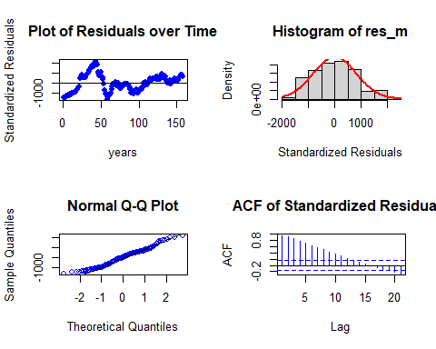

Residual Analysis for Polynomial DLM:

1. The data points are below the line at the start and below the line at the end of the trend. Randomness is seen to some extent. So, we cannot decide anything at this stage. Further analysis is required.
2. From normal distribution curve, the distribution is almost symmetric and requires some transformation to make it symmetric. This suggests the non - stationary in the series.
3. The data at the tails is deviated more leaving some part on the line suggesting there is no normality in the trend.
4. There are significant lags in Autocorrelation plot suggesting that the stochastic component is not white noise.

This analysis is not enough and we still require a better model than this. Therefore, let us fit Koyck model.

# Koyck model

# Koyk DLM  
  
Koyck_DLM_GOLD = koyckDlm(x = as.vector(x) , y = as.vector(y))  
summary(Koyck_DLM_GOLD)

##   
## Call:  
## "Y ~ (Intercept) + Y.1 + X.t"  
##   
## Residuals:  
## Min 1Q Median 3Q Max   
## -682.19 -105.44 15.86 135.04 783.60   
##   
## Coefficients:  
## Estimate Std. Error t value Pr(>|t|)   
## (Intercept) 1.902e+02 8.958e+01 2.123 0.0353 *   
## Y.1 9.635e-01 1.909e-02 50.469 <2e-16 ***  
## X.t 2.595e-03 4.304e-02 0.060 0.9520   
## ---  
## Signif. codes: 0 '***' 0.001 '**' 0.01 '*' 0.05 '.' 0.1 ' ' 1  
##   
## Residual standard error: 201.4 on 157 degrees of freedom  
## Multiple R-Squared: 0.9488, Adjusted R-squared: 0.9481   
## Wald test: 1454 on 2 and 157 DF, p-value: < 2.2e-16   
##   
## Diagnostic tests:  
## NULL  
##   
## alpha beta phi  
## Geometric coefficients: 5205.15 0.002595168 0.9634602

Hypotheses : H0 : The data doesn′t fit the Koyck distributed lag model. HA : The data fits the Koyck distributed lag model.

Interpretations: Walt test - statistic is 1454 R - squared is 0.9488 Adjusted R - squared is 0.9481 Degrees of freedom - DF are (2, 157) p - value (0.01) is < 0.05 and therefore, it is statistically significant. Therefore, Null hypothesis is rejected. Hence, the model fits the Koyck distributed lag model.

This model suggests that there is only 94.88% of data variance. Suggesting that the model explains only 94.81% of the trend. Which implies that the model performs better on the series data.

Now let us perform residual analysis.

## Residual analysis

res_analysis(residuals(Koyck_DLM_GOLD))

## 2 3 4 5 6 7   
## -241.501847 -19.941014 34.794408 -74.164805 -62.804566 25.037109   
## 8 9 10 11 12 13   
## 18.090550 -101.347005 30.647193 -158.368909 35.444407 -93.187885   
## 14 15 16 17 18 19   
## 17.335147 -24.472523 -75.470243 -17.894108 8.052784 -46.841840   
## 20 21 22 23 24 25   
## -46.281120 51.258059 54.190387 103.176531 62.675283 783.597749   
## 26 27 28 29 30 31   
## -15.106929 195.430673 114.025923 -236.178619 51.508989 -85.056058   
## 32 33 34 35 36 37   
## 111.645019 26.326113 234.347452 112.043882 189.961258 127.353685   
## 38 39 40 41 42 43   
## 76.785963 182.495229 205.640687 216.230979 8.313365 -84.697870   
## 44 45 46 47 48 49   
## 94.609100 368.531583 246.291461 -130.325698 -124.255990 -682.191909   
## 50 51 52 53 54 55   
## -6.949305 -250.561461 252.136641 131.076974 -422.745277 -278.070154   
## 56 57 58 59 60 61   
## 154.859912 -586.453849 -672.623401 -357.673534 -72.558393 -240.994134   
## 62 63 64 65 66 67   
## -248.074746 162.069818 148.039796 12.088043 80.582907 252.743702   
## 68 69 70 71 72 73   
## 196.729778 225.851923 -112.408332 45.021792 146.051604 -300.757456   
## 74 75 76 77 78 79   
## 28.766257 218.588235 -73.818187 -397.474250 -160.014100 146.896532   
## 80 81 82 83 84 85   
## -97.603017 166.584126 72.188400 -77.834041 147.536738 -13.629163   
## 86 87 88 89 90 91   
## 57.186684 -8.943604 -43.328466 -124.964282 -148.048039 -183.015411   
## 92 93 94 95 96 97   
## -160.690266 -334.811584 244.666577 -211.161442 -115.196818 170.590812   
## 98 99 100 101 102 103   
## 26.052338 -2.081939 14.374857 -364.592680 -41.490375 110.797629   
## 104 105 106 107 108 109   
## 12.110461 31.296102 95.506440 -46.166498 117.311637 212.518196   
## 110 111 112 113 114 115   
## 204.189418 -147.593581 176.757270 -259.640926 107.370579 -270.138152   
## 116 117 118 119 120 121   
## 330.327618 85.711763 199.468922 -101.692046 39.250827 -146.241724   
## 122 123 124 125 126 127   
## 206.536201 -8.533981 71.409639 9.116362 -85.528604 243.937892   
## 128 129 130 131 132 133   
## 13.159571 -316.023855 207.954305 -199.494856 90.121425 165.678620   
## 134 135 136 137 138 139   
## 355.471542 -15.224607 -68.246721 18.061000 -306.857793 235.534004   
## 140 141 142 143 144 145   
## -446.159408 -167.019441 220.472049 -71.294648 123.049215 -286.974805   
## 146 147 148 149 150 151   
## -118.495668 190.185918 158.042262 131.375051 -133.007967 332.835999   
## 152 153 154 155 156 157   
## -103.123725 3.113990 -115.422781 102.945152 223.506743 -29.463322   
## 158 159 160 161   
## 98.988163 158.918386 64.963948 -163.517963

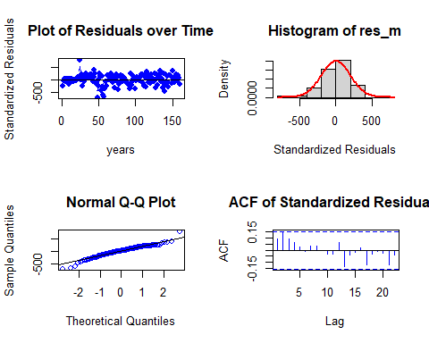

Residual Analysis for Koyck DLM:

1. The data points are below the line at both the start and end of the trend. Randomness is not seen here.
2. From normal distribution curve, the distribution is almost symmetric. This suggests a good fit with a very few data falling outside the normal curve indicating Kurtosis.
3. The data at the tails is deviated but is normal for most part of the line suggesting normality in the trend.
4. There are no significant lags in Autocorrelation plot suggesting that the stochastic component is white noise.

So far this is the best model but let us fit ardlDlm model to check whether it fits better than Koyck model or not.

# Autoregressive distributed lag model

for (i in 1:10){  
 for(j in 1:5){  
 model_4 = ardlDlm(x = as.vector(x) , y = as.vector(y), p = i , q = j )  
 cat("p = ", i, "q = ", j, "AIC = ", AIC(model_4$model), "BIC = ", BIC(model_4$model),"\n")  
 }  
}

## p = 1 q = 1 AIC = 2140.897 BIC = 2156.273   
## p = 1 q = 2 AIC = 2128.524 BIC = 2146.938   
## p = 1 q = 3 AIC = 2113.99 BIC = 2135.428   
## p = 1 q = 4 AIC = 2102.754 BIC = 2127.204   
## p = 1 q = 5 AIC = 2092.194 BIC = 2119.643   
## p = 2 q = 1 AIC = 2128.627 BIC = 2147.04   
## p = 2 q = 2 AIC = 2130.523 BIC = 2152.005   
## p = 2 q = 3 AIC = 2115.89 BIC = 2140.39   
## p = 2 q = 4 AIC = 2104.694 BIC = 2132.2   
## p = 2 q = 5 AIC = 2094.14 BIC = 2124.639   
## p = 3 q = 1 AIC = 2118.109 BIC = 2139.547   
## p = 3 q = 2 AIC = 2120.027 BIC = 2144.528   
## p = 3 q = 3 AIC = 2117.305 BIC = 2144.868   
## p = 3 q = 4 AIC = 2105.731 BIC = 2136.293   
## p = 3 q = 5 AIC = 2095.264 BIC = 2128.812   
## p = 4 q = 1 AIC = 2107.002 BIC = 2131.452   
## p = 4 q = 2 AIC = 2108.914 BIC = 2136.42   
## p = 4 q = 3 AIC = 2106.276 BIC = 2136.839   
## p = 4 q = 4 AIC = 2107.456 BIC = 2141.074   
## p = 4 q = 5 AIC = 2097.01 BIC = 2133.608   
## p = 5 q = 1 AIC = 2094.908 BIC = 2122.357   
## p = 5 q = 2 AIC = 2096.86 BIC = 2127.359   
## p = 5 q = 3 AIC = 2094.144 BIC = 2127.692   
## p = 5 q = 4 AIC = 2095.425 BIC = 2132.023   
## p = 5 q = 5 AIC = 2097.324 BIC = 2136.972   
## p = 6 q = 1 AIC = 2083.087 BIC = 2113.521   
## p = 6 q = 2 AIC = 2084.993 BIC = 2118.471   
## p = 6 q = 3 AIC = 2081.777 BIC = 2118.298   
## p = 6 q = 4 AIC = 2083.115 BIC = 2122.68   
## p = 6 q = 5 AIC = 2084.976 BIC = 2127.584   
## p = 7 q = 1 AIC = 2072.69 BIC = 2106.097   
## p = 7 q = 2 AIC = 2074.588 BIC = 2111.032   
## p = 7 q = 3 AIC = 2071.471 BIC = 2110.952   
## p = 7 q = 4 AIC = 2072.806 BIC = 2115.324   
## p = 7 q = 5 AIC = 2074.667 BIC = 2120.221   
## p = 8 q = 1 AIC = 2060.657 BIC = 2097.022   
## p = 8 q = 2 AIC = 2062.526 BIC = 2101.922   
## p = 8 q = 3 AIC = 2059.768 BIC = 2102.194   
## p = 8 q = 4 AIC = 2060.894 BIC = 2106.35   
## p = 8 q = 5 AIC = 2062.836 BIC = 2111.323   
## p = 9 q = 1 AIC = 2046.919 BIC = 2086.229   
## p = 9 q = 2 AIC = 2048.65 BIC = 2090.985   
## p = 9 q = 3 AIC = 2046.025 BIC = 2091.383   
## p = 9 q = 4 AIC = 2046.982 BIC = 2095.364   
## p = 9 q = 5 AIC = 2048.757 BIC = 2100.163   
## p = 10 q = 1 AIC = 2036.551 BIC = 2078.793   
## p = 10 q = 2 AIC = 2038.268 BIC = 2083.528   
## p = 10 q = 3 AIC = 2035.644 BIC = 2083.92   
## p = 10 q = 4 AIC = 2036.587 BIC = 2087.88   
## p = 10 q = 5 AIC = 2038.35 BIC = 2092.661

p = 10 and q = 1 has the least AIC and BIC scores.

# ARDLM model  
  
AR_DLM_GOLD = ardlDlm(x = as.vector(x) , y = as.vector(y), p = 10 , q = 1 )  
summary(AR_DLM_GOLD)

##   
## Time series regression with "ts" data:  
## Start = 11, End = 161  
##   
## Call:  
## dynlm(formula = as.formula(model.text), data = data, start = 1)  
##   
## Residuals:  
## Min 1Q Median 3Q Max   
## -577.16 -104.00 3.19 123.44 692.04   
##   
## Coefficients:  
## Estimate Std. Error t value Pr(>|t|)   
## (Intercept) 251.32788 106.98266 2.349 0.02023 *   
## X.t -1.32788 0.31171 -4.260 3.76e-05 ***  
## X.1 1.22622 0.46170 2.656 0.00884 **   
## X.2 0.01481 0.46792 0.032 0.97479   
## X.3 -0.10766 0.47156 -0.228 0.81975   
## X.4 -0.30652 0.47267 -0.648 0.51775   
## X.5 0.84867 0.47345 1.793 0.07524 .   
## X.6 -0.60306 0.47801 -1.262 0.20922   
## X.7 0.67531 0.47880 1.410 0.16066   
## X.8 -0.99071 0.47783 -2.073 0.04000 *   
## X.9 0.56889 0.47228 1.205 0.23044   
## X.10 -0.02612 0.31568 -0.083 0.93418   
## Y.1 0.96236 0.02063 46.656 < 2e-16 ***  
## ---  
## Signif. codes: 0 '***' 0.001 '**' 0.01 '*' 0.05 '.' 0.1 ' ' 1  
##   
## Residual standard error: 195.8 on 138 degrees of freedom  
## Multiple R-squared: 0.9435, Adjusted R-squared: 0.9386   
## F-statistic: 192.2 on 12 and 138 DF, p-value: < 2.2e-16

Hypotheses : H0 : The data doesn′t fit the Autoregressive distributed lag model. HA : The data fits the Autoregressive distributed lag model.

Interpretations: F - statistic is 194.9 R - squared is 0.9435 Adjusted R - squared is 0.9386 Degrees of freedom - DF are (12, 138) p - value (0.01) is < 0.05 and therefore, it is statistically significant. Therefore, Null hypothesis is rejected. Hence, the model fits the Autoregressive distributed lag model.

This model suggests that there is only 94.35% of data variance. Suggesting that the model explains only 94.35% of the trend. Which implies that the model shows some trend.

Let us perform residual analysis on this model.

## Residual analysis

res_analysis(residuals(AR_DLM_GOLD))

## Time Series:  
## Start = 11   
## End = 161   
## Frequency = 1   
## 11 12 13 14 15 16   
## -201.2390881 -3.4773197 -144.1721026 -66.3819403 -36.3127014 -116.4198852   
## 17 18 19 20 21 22   
## -44.2162022 -17.7380897 -87.3200898 -78.1046315 38.9515009 -0.1158940   
## 23 24 25 26 27 28   
## 61.8817397 45.0861630 692.0405257 -34.6406303 149.9144784 88.5401013   
## 29 30 31 32 33 34   
## -240.3521831 105.7469445 -17.8727754 167.8403439 151.1742431 198.2380282   
## 35 36 37 38 39 40   
## 45.7366623 189.7363529 135.1809531 30.3179711 176.4898353 151.9974716   
## 41 42 43 44 45 46   
## 234.9216984 -41.5154524 -197.9216435 139.2993535 354.7192247 240.9378974   
## 47 48 49 50 51 52   
## -76.4538363 -95.4598999 -577.1628059 -29.7908302 -198.9178025 142.6129432   
## 53 54 55 56 57 58   
## 117.2790747 -509.1100015 -202.0185587 13.0499053 -465.1765959 -489.9860494   
## 59 60 61 62 63 64   
## -330.3216937 -43.0700463 -126.0379194 2.9485130 69.1834875 -11.6248336   
## 65 66 67 68 69 70   
## -74.2598584 165.9060949 54.5609150 140.4542129 194.3081114 -55.9271795   
## 71 72 73 74 75 76   
## 141.3292931 102.7104642 -339.4529645 14.0843656 226.9475683 -109.1446845   
## 77 78 79 80 81 82   
## -206.6487125 -102.7599214 47.6012016 -58.1744227 195.7745494 49.3909563   
## 83 84 85 86 87 88   
## -111.0952351 142.0957447 -32.0582927 107.6291365 3.1948962 -76.1791361   
## 89 90 91 92 93 94   
## -134.3995717 -103.9112833 -152.2865721 121.0861953 -238.3836291 120.5497557   
## 95 96 97 98 99 100   
## -41.1166916 -144.6827117 43.7535942 54.4191557 -68.2465758 0.9376417   
## 101 102 103 104 105 106   
## -274.9011232 -124.1617334 89.5437129 -4.9617717 143.0758142 154.7200243   
## 107 108 109 110 111 112   
## -142.0409544 97.1067500 221.3119690 155.3026481 -241.4058348 -37.9766222   
## 113 114 115 116 117 118   
## -229.5822360 91.9271040 -345.3178975 375.3628010 57.2752472 79.5026873   
## 119 120 121 122 123 124   
## -104.0840629 -5.3667868 -166.2536265 258.7687001 -23.2980844 22.2306959   
## 125 126 127 128 129 130   
## 12.2676277 -150.4848076 256.7233384 -61.5443116 -330.0018822 222.5969453   
## 131 132 133 134 135 136   
## -191.9031121 141.9733325 293.2727331 384.3126877 -74.9500836 34.9134962   
## 137 138 139 140 141 142   
## -44.0934078 -281.8841263 149.6407815 -407.9804338 -81.3726683 289.2763956   
## 143 144 145 146 147 148   
## -240.7039552 93.3776883 -173.9722038 10.7557846 125.7989355 109.8102475   
## 149 150 151 152 153 154   
## 347.2542476 -80.1461200 339.3249824 -157.9966848 50.4672704 -200.3355514   
## 155 156 157 158 159 160   
## 112.9116274 7.6170570 59.4861478 39.7518466 205.6933992 98.5656200   
## 161   
## -94.1005839

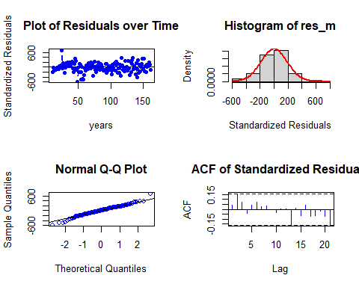

Residual Analysis for Auto Regressive DLM:

1. The data points are below the line at both the start and end of the trend. Randomness is not seen here.
2. From normal distribution curve, the distribution is almost symmetric. This suggests a good fit with a very few data falling outside the normal curve indicating Kurtosis.
3. The data at the tails is deviated but is normal for most part of the line suggesting normality in the trend.
4. There are no significant lags in Autocorrelation plot suggesting that the stochastic component is white noise.

Even though Auto Regressive DLM shown better performance, Koyck model fits better with 94.88% variance.

Finally, the Koyck model with Gold got 94.88% R - Squared. Where as, with respect to Copper it is 94.85%. But the higher Correlation coefficient in Copper making it the best model. But let us check it by finding the multi-collinearity.

vif(Koyck_DLM_copper$model) > 10

## Y.1 X.t   
## FALSE FALSE

vif(Koyck_DLM_GOLD$model) > 10

## Y.1 X.t   
## FALSE FALSE

Both the models doesn’t suffer from multi-collinearity. But Correlation coefficient being the crutial factor Copper series should be considered on top of Gold series. Hence, Koyck model with copper will be a better model.

Overall it is suggesting that Koyck DLM is the best fit model among all DL models.

# Conclusion

Finally, we can conclude that,

1. The series data is non - stationary.
2. The components like trend, remainder and seasonality effected the stationarity of the series data.
3. The best fit DLM model is Koyck model with r-squared of 0.9485.